1. Delete empty folder: delete when it is empty folder and it is folder

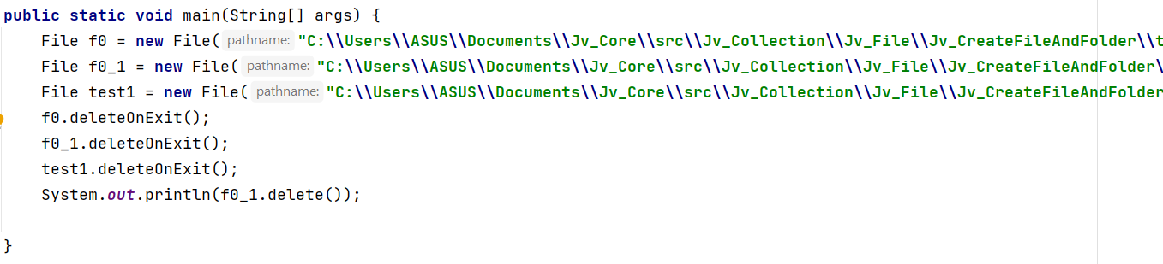

2. Delete not empty folder: the difference between deleleOnExist and delete is fisrt one won’t appear error and converse delete have error

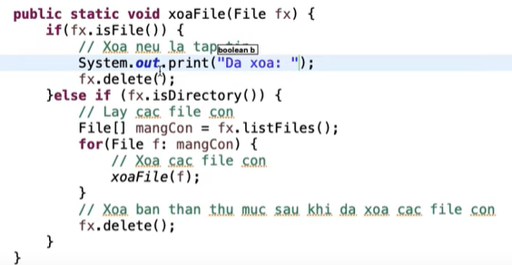

3. Delete by Files

